Problem-1

Create a Navigation bar using HTML (With out CSS and Bootstarp), it should contain

-> Home

-> Signup

-> Login

-> Search Bar.

Code:

<!DOCTYPE html>

<html lang="en">

<head>

<meta charset="UTF-8">

<meta name="viewport" content="width=device-width, initial-scale=1.0">

<title>Simple Navigation Bar</title>

</head>

<body>

<nav>

<ul>

<li><a href="/">Home</a></li>

<li><a href="/signup">Signup</a></li>

<li><a href="/login">Login</a></li>

<li>

<form action="/search" method="get">

<input type="text" name="q" placeholder="Search...">

<button type="submit">Search</button>

</form>

</li>

</ul>

</nav>

</body>

</html>

Output:

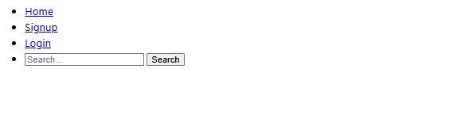

Github link : <https://github.com/MohammedObaidUllah/FEWD/blob/main/navbar.html>

Problem-2

Create a Portfolio page using HTML , it should contain

-> Self introduction

-> skills

-> projects/work experiences (Git links)

-> Feedback /achivements

-> Education profile

-> Contact information.(Social media /phone /email)

Code:

<!DOCTYPE html>

<html lang="en">

<head>

<meta charset="UTF-8">

<meta name="viewport" content="width=device-width, initial-scale=1.0">

<title>Portfolio</title>

</head>

<body>

<header>

<h1>Welcome to My Portfolio</h1>

</header>

<section id="introduction">

<h2>Self Introduction</h2>

<p>Hello! My name is Mohammed ObaidUllah. I am a passionate WebDeveloper. I love working on innovative projects and learning new skills.</p>

</section>

<section id="skills">

<h2>Skills</h2>

<ul>

<li>Programming Languages: C, C++, Python, Java.</li>

<li>Web Development: HTML, CSS, JavaScript, BootStrap.</li>

<li>Database Management: MySQL, MongoDB.</li>

<li>Other Skills: Problem Solving, Team Collaboration.</li>

</ul>

</section>

<section id="projects">

<h2>Projects / Work Experiences</h2>

<ul>

<li><a href="[GitHub Link 1]">Personal Portfolio Website</a> - Designed and developed a responsive portfolio website to showcase my skills, projects, and contact information using HTML, CSS, and JavaScript.</li>

<li><a href="[GitHub Link 2]">Task Management App</a> - Built a full-stack web application to manage daily tasks, including features like adding, editing, and deleting tasks, with MongoDB, Express.js, and Node.js.</li>

<li><a href="[GitHub Link 3]">E-commerce Platform</a> - Created a simple e-commerce platform for small businesses, allowing users to browse products, add them to a cart, and checkout, using React and Firebase.</li>

<li><a href="[GitHub Link 4]">Weather App</a> - Developed a weather application that displays real-time weather data for any city using the OpenWeatherMap API and vanilla JavaScript.</li>

<li><a href="github link">GitHub link</a> - A link to github repository for all the projects.</li>

</ul>

</section>

<section id="feedback">

<h2>Feedback / Achievements</h2>

<ul>

<li>Awarded "Best Innovative Project" for the Task Management App during Marathon 151.</li>

<li>Successfully completed a professional certification in Python.</li>

<li>Received excellent feedback from clients for developing user-friendly and robust applications.</li>

</ul>

</section>

<section id="education">

<h2>Education Profile</h2>

<ul>

<li><strong>Keshav Memorial Institute of Technology.</strong>

<p>B. tech. in Computer Science and Engineering - CGPA: 8.85/10</p></li>

<li><strong>MS Junior College.</strong>

<p>11-12 SSC: 940/1000</p></li>

<li><strong>Ravindra Bharathi School</strong>

<p>SSC(Secondary School Certificate) -GPA: 9/10.</p></li>

</ul>

</section>

<section id="contact">

<h2>Contact Information</h2>

<p>Email: <a href="mailto:mohammedobaidullah2004@gmail.com">mohammedobaidullah2004@gmail.com</a></p>

<p>Phone: <a href="tel:+9391307881">+9391307881</a></p>

<p>Social Media:

<ul>

<li><a href="[LinkedIn URL]">LinkedIn</a></li>

<li><a href="[Twitter URL]">Twitter</a></li>

<li><a href="[GitHub URL]">GitHub</a></li>

</ul>

</p>

</section>

</body>

</html>

Output:

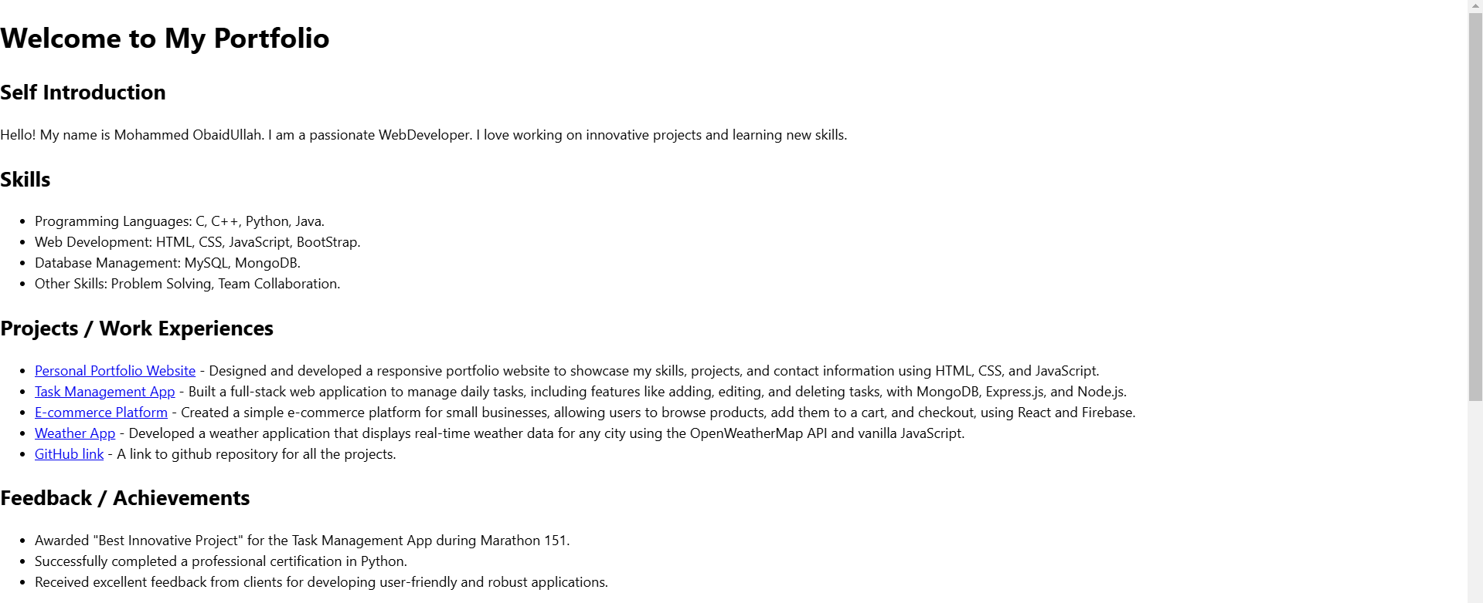

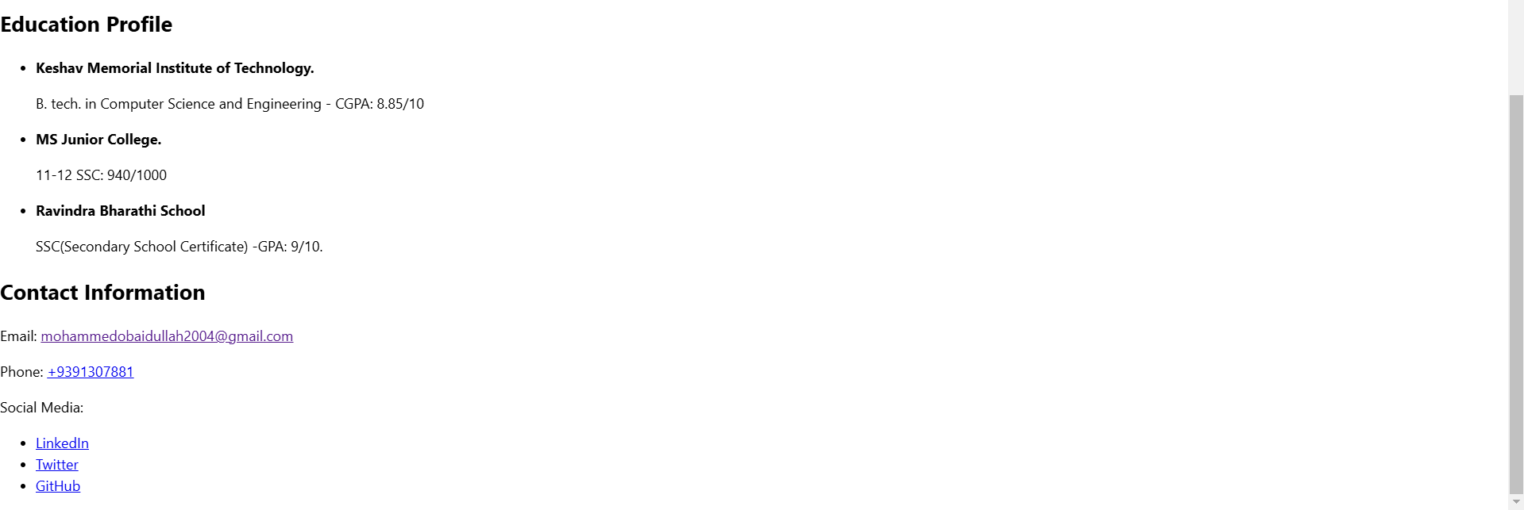

Github link: <https://github.com/MohammedObaidUllah/FEWD/blob/main/portfolio.html>